AERONAUTICS INSTITUTE OF TECHNOLOGY (ITA)
Air Transport and Airport Infrastructure Postgraduate Program (PG-EIA)

PRELIMINARY RESEARCH PROPOSAL: PARTIAL REQUIREMENT FOR THE ADMISSION EXAM (MASTER AND DOCTORATE – PG-EIA /ITA )
Fill in all fields in red (note: This information can be updated after enrolment):
Candidate's Full Name: | Your name
Concentration Areas (EIA-I or EIA-T): | EIA-T
Modality (Masters, Doctorate or PMG): | Masters
Name of potential advisor (previous contact with the advisor is mandatory for review of this plan. However, the plan is authored by the candidate. | Here you cand find the list of professors:  https://infraita.wordpress.com/professores/
Provisional title of the work: | New technologies applied to detect passengers with excess baggage

PROJECT SUMMARY
Include here a summary of 120 to 140 words, stating: the context of the problem, its motivation, objectives and methods to be used.
KEYWORDS (3 to 5 words): Technology; Airports; Neural networks.

1. JUSTIFICATION
Include here a text of 150 to 300 words, making clear the theoretical gap that your research aims to fill. Include in your analysis recent scientific works, adopting a consistent standard for citations (e.g., ABNT, IEEE, APA). Include at the end of the document all the cited references.
Here you must show that your work has the potential to expand existing knowledge. A tip is to read the recommendations for future works at the end of theses, dissertations and scientific articles.
Example 1 ITA: http://www.bdita.bibl.ita.br/ (requires free registration)
Example 2 Google Scholar: https://scholar.google.com/
Example 3 Research Gate: https://www.researchgate.net/
Example 4 Science Direct: https://www.sciencedirect.com/

2. REASEARCH OBJECTIVES
Make your objective clear here in one sentence. If deemed necessary, include up to 5 'bullets' with specific objectives (each one in one sentence).

3. THEORETICAL FOUNDATION
Write here some description of the fundamental bibliography. Prefer recent scientific work. Here you can present timelines, summary tables, figures, equations, etc. In any case, be sure to show how your work fits in this literature. An example of a literature review presentation is given in Table 1.
Table 1: Example of literature analysis
Author | A validation model is defined?
[1] | Yes
[2] | No*
*: You can use explanatory notes
Source: Prepared by the Author.

4. METHODOLOGY
Write here a text pointing out the data, the techniques, the resources that will be needed. Don't forget to point out an organized sequence of activities. See the systematization exemplified in Figure 1.
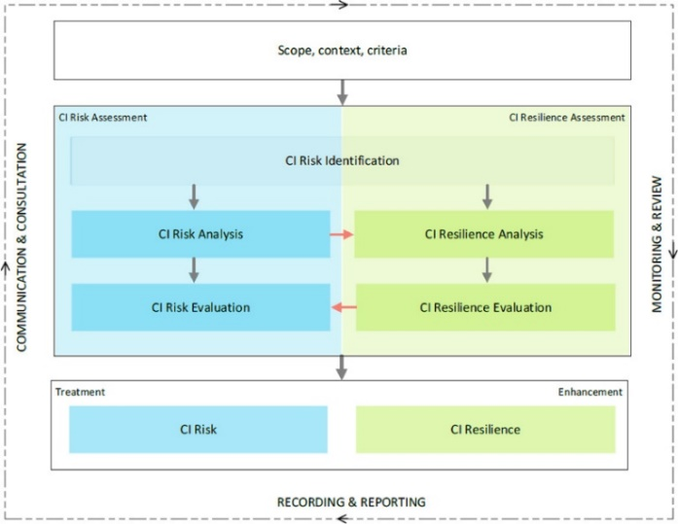
Figure 1– Example of a diagram for the presentation of the methodology. Source: [2]

Indicate the techniques and software that will be used. E.g.: “ Econometric analysis in GRETL free software , using multivariate regression” .

References

[1] | Osman Balci, "Verification, Validation and Accreditation of Simulation Models," in Proceedings of the 2017 Winter Simulation Conference, 1997, pp. 135-141.
[2] | Adel Mottahedi, Farhang Sereshki, Mohammad Ataei, Ali Nouri Qarahasanlou, and Abbas Barabadi, "Resilience estimation of critical infrastructure systems: Application of expert judgment," Reliability Engineering & System Safety, vol. 215, 2021. [Online]. https://www.sciencedirect.com/science/article/pii/S0951832021003689

(Include here all cited references)

INSTRUCTIONS
The structure above is a minimum reference. If necessary, include sections and subsections (e.g., timelines, lists of published works, lists of technical works you are the author of, providing links if applicable). For a master's degree application, the complete project must span 5 to 10 pages, for a doctoral degree application, 10 to 20 pages.
To submit the application to ITA, please carefully review this document and generate a PDF of less than 20Mb. Do not change the layout of the first page.

